Farming Returns ‘1994 and 2020’
Comparing the Two
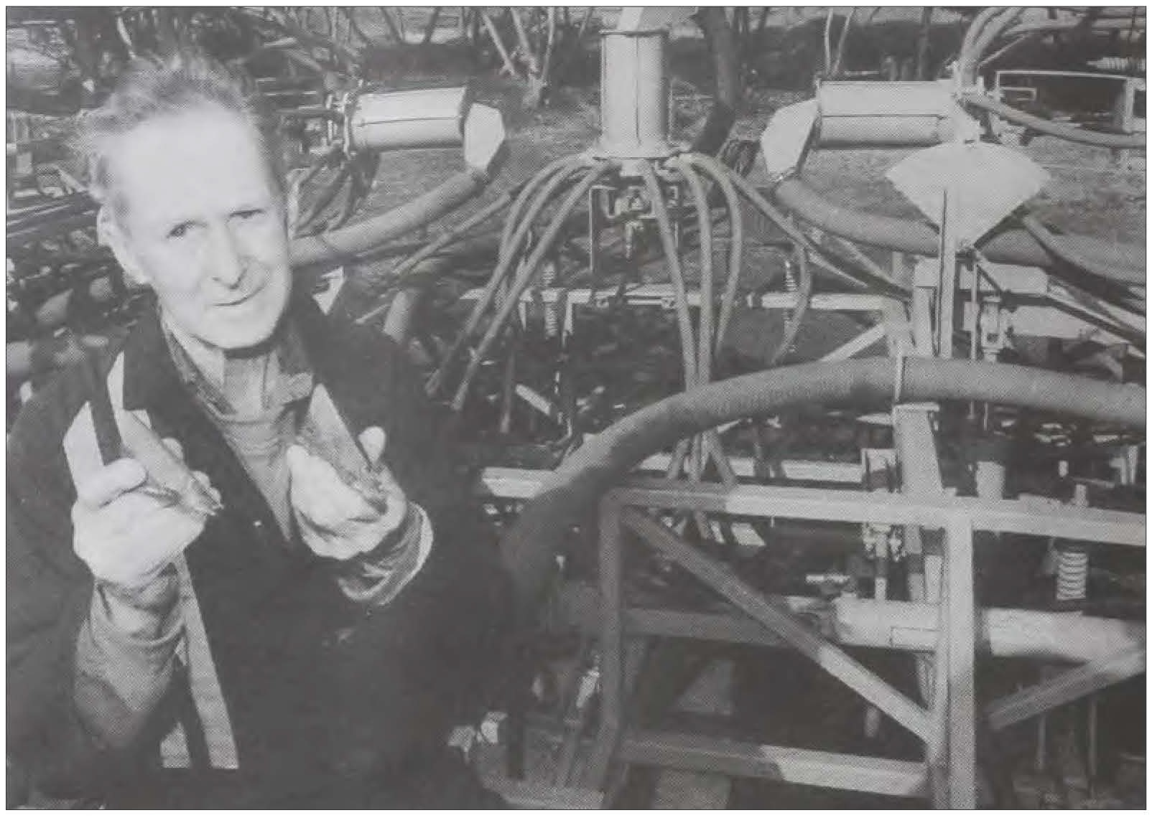Social isloation and the absence of televised football has led one local resident to engage in the cleaning out of his shed, which yielded an unexpected treasure.

In a pile of newspapers, the observant gentleman spotted a copy of "Stock & Land" dated Thursday, June 2, 1994, with a cover price of $1.50.
He decided to compare
some of the prices noted by the journal with today's prices.
At Wycheproof, 4 \12-year­ old 1st. cross ewes, with Poll Dorset lambs at foot, sold for
$44 per head. At a recent sale, similar outfits made $380 per head.
In 1994, Merino ewes with
Poll Dorset lambs made $37.

Recently similar outfits made
$259 to $320 per head.
Last week, heavy lambs traded for from $240 to $280 per head. Twenty-six years ago, heavy lambs made from
$39.72 down to $31.04.
Last week, heavy x-bred ewes made up to $280, while
26 years ago, similar sheep made from $30.60 to $20.80.
Heavy Merino ewes traded between $26.38 and $18.13. Heavy wethers traded between
$35.50 and $19.70, while last

week 40kg wethers traded up to $280.
Twenty-six years ago, top
price wheat landed in Mel­ bourne made $132 per tonne, compared with today's price of $400 per tonne.
Today, cereal hay trades for around $300 per tonne -26 years ago the price was $80 to
$100 per tonne.
Crops and Pastures
In the same edition, in a
two-part feature under the banner, "Crops and Pastures", "Stock & Land" grains writer Carol Trailor interviews Charlton district farmer, Terry Lane and his wife, Marion, ex­ ploring the impact sowing vetch following wheat to achieve outstanding yields, and the Lanes' move to mini­

Under the sub-heading, "Vetch lifts yields in whole­ farm plan", Carol reported as follows:
"Cropping wheat following vetch to achieve outstanding yields has typified the new ap­ proach to farming taken by Terry and Marion Lane, Charl­ ton, Vic., in the past 10 years. "Mr Lane said he switched
to a cropping-only farm
management program about four years ago to achieve better returns.
"About the same time, he began sowing vetch.
"He is now considering in­
creasing vetch because of the outstanding yields achieved in wheat crops following the green manuring of the vetch.
"The Lanes, who run a 404 hectare property and share farm another 430ha, began their whole-farm cropping program after receiving advice from the Agriculture Depart­ ment. Mr Lane said by using

• Charlton farmer, Terry Lane, as pictured in the "Stock & Land " of Thursday, June 2, 1994, with the caption that included "Terry Lane, Charlton, Vic., shows the tungsten-tipped Keech

parison 'with the combine he used to use. "

year will incorporate 24ha of all, but this year he will only Minimum Tillage
Arapiles for the first time. cultivate it once. On the same page, under
"The Lanes planted the "He also gives the land a the sub-heading, "Minimum vetch for seed the first season 'cross-work' and on paddocks tillage means switch in rna­ but since have been green rna- to be sown with cereals he pre- chinery", Carol reported as follows: nuring it and grazing it until drills urea at about 60 kilo- "Amove to minimum tillage November before leaving it grams/ha, although this is meant a change in machinery fallow and sowing wheat on increased to up to 1OOkg/ha for Charlton, Vic. graingrowers the ground the following year. for land to be sown to canola Terry and Marion Lane.
"Last year the wheat on and on soil which appears to "The Lanes switched last paddocks following vetch lack fertility. year from using a 4.5 metre Yielded 5.5 tonnes a hectare b. lt. t d d
and the previous season aver- "The soil pH is about 8 to com me cu tva or an see er
8.5percent, andMrLanesaid to a 9.1 metre T220 Gyral
aged nearly 6.7 tonnes/ha. he found the soil needed zinc. tilther fitted wth a Gyral two- "The whole-farm average behind air seeder bin with 30
wheat yield last year was 3.7 "Soil tests in 1985 high- centimetre spacings.
tonnes/ha on a 80ha paddock lighted a zinc deficiency in the "Mr Lane said the new and 5.5 tonnes/ha on a lOOha soil and Mr Lane has been tilther provided more clearance
Paddock. In the past, Mr Lane working since then to improve than the combine and the
sowed about 1 OOha a year of the problem. He applies 70kg/ha switch was a key factor in his
vetch, but this year will only of super and 2.5kg/ha of zinc. new minimum tillage, trash-
be sowing 56ha as he has 'too "Mr Lane quoted a report retention program.
many other crops to sow'. prepared by crop specialist '"It has a hydraulically­ "The Lanes have sown the John Land, which said there- driven motor under the three vetch at about 25 kilograms a sult had been "a dramatic in- heads which help to evenly hectare with the first autumn crease in pasture growth and circulate the seed and stop
break but this year built this up improved grain yield." blockages,' Mr Lane said.
to 40kg/ha for better coverage. "Mr Lane applt.es Gra·n

minimum tillage and direct­
drilling trash would be put
1 '"I've sown a lot of seed It was sown dry about two Legume super wt. th zt.nc to which hasn't been cleaned months ago to anticipate the legumes, which adds sulphur

back into the ground and even­
autumn break· to the soil, which, he said, was
thoroughly, without any blockages,'

tually break down to return
"Pre t·o sl the Lanes "He said he changed be-

nutrients to the soil.
v u y,
grazed their vetch 'right down'
lacking in the double super he used to use.

cause the combine, although

"'Farming has changed im­ mensely in the last 1 0 years or so from the old method offal­ lowing cereals and pastures,' Mr Lane said. He said in that
10 years he had radically changed his "whole farming practice'.
'"I have proved that you can get results, especially by following the vetch with the wheat,' Mr Lane said, 'My aim with green manuring is to try to boost the protein and fertility fo the wheat the fol­ lowing year.'
"The all-cropping program led to a move toward mini­ mum tillage croping practices for the Lanes, with some min­ imum tillage cultivation and some direct drilling. (See story this page)
"The Lanes intend to sow canola for the first time this year.
Other Crops
"Other crops include chick
peas (1OOha), Meering and Rosella wheat (240ha), field peas (160ha) safflower (50ha) and barley (100). The Lanes grow Schooner barley and this
until November and broke the going through a lot of trash,
soil up with the first rains but "He sows barley at had a lot of blockages on crops this year will turn the whole 60kg/ha. Last year the barley such as chick peas.
crop in without grazing. Mr was eaten out by mice andre- '"We decided to go to the Lane said this was because of sown, which Mr Lane said airseeder and it cuts double the Agriculture Department ad- 'significantly decreased the width,' he said.
vice that he would probably yield'. '"It uses heavier Keech get more nitrogen input if he "He sows peas at lOOkg/ha points which are tungsten did not graze down. to yield about 2.2 tonnes/ha. tipped and they have been
"He said the only problem Chick peas are sown at similar hardfaced by Gyral. '
in following vetch with a cereal rates, but yield slightly less - "Mr Lane said there was was its presence as a weed in about two tonnes/ha. 'no comparison' between the a cereal crop, but he controlled "The canola will be sown at combine and his new tilther. this with about 85mm ofLontrel five kilograms/ha, and Mr '"I've done about 3000 applied to wheat at early tillering. Lane said the best safflower acres with this set (of points)
"His rotation is vetch, fol- yields were achieved when and I am just starting to re-
lowed by wheat, followed by sown at about 15kg/ha." place them now,' he said." legume. He said this was a l---------------'-----------­
'very flexible rotation '.
Canola will be planted in the place of wheat this year.
"On the high-yielding wheat
crops, Mr Lane said he found it harder to get high protein , but was trying to build up nitrogen and nutrient levels in the soil.

Preparation
"His ground preparation for
all crops includes working up the ground about twice with a chisel plough or cultivator to combat rhizoctonia and take-

